1. BIRD-FLY OR NOT
AIM
To write a Prolog program to determine whether a particular bird can fly or not using facts, rules, and queries.
OBJECTIVE
· To store bird information as Prolog facts.
· To identify birds that cannot fly.
· To use a rule to determine the flying ability of a bird.
· To execute queries for checking whether a particular bird can fly.
ALGORITHM
1. Start.
2. Define the list of birds as facts.
3. Define birds that cannot fly.
4. Create the rule can_fly(Bird).
5. Enter the name of a bird as a query.
6. Check whether the bird is present in the database.
7. If the bird is not in the cannot_fly list, return true.
8. Otherwise, return false.
9. Display the result.
10. Stop.
FLOWCHART
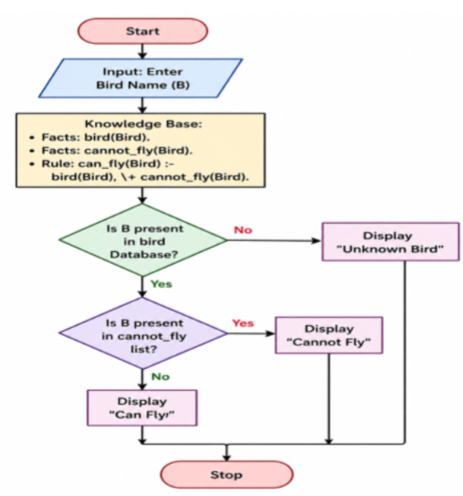
CODE:
bird(eagle).
bird(parrot).
bird(pigeon).
bird(sparrow).
bird(penguin).
bird(ostrich).
cannot_fly(penguin).
cannot_fly(ostrich).
can_fly(Bird) :-
bird(Bird),
\+ cannot_fly(Bird).
OUTPUT
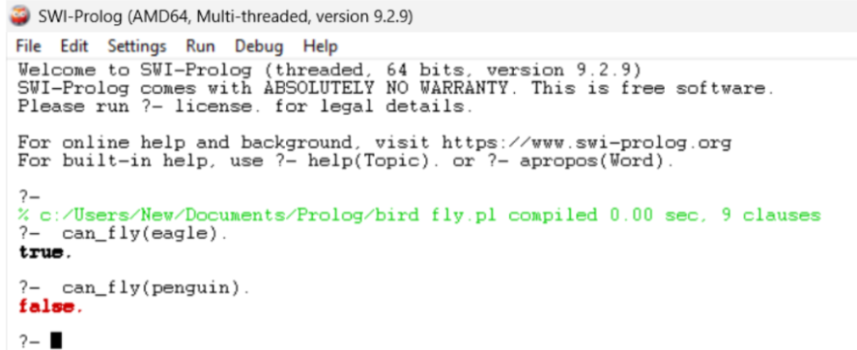
RESULT:
Thus, the Prolog program was successfully implemented to determine whether a particular bird can fly or not, and the required queries produced the expected results.

